# Python Functions

A Function is a self-block of code.

A Function can be called as a section of a program that is written once and can be executed whenever required in the program, thus making code reusability.

A Function is a subprogram that works on data and produce some output.

**Types of Functions:**

There are two types of Functions.

a) Built-in Functions: Functions that are predefined. We have used many predefined functions in Python.

b) User- Defined: Functions that are created according to the requirements.

**Defining a Function:**

A Function defined in Python should follow the following format:

1) Keyword def is used to start the Function Definition. Def specifies the starting of Function block.

2) def is followed by function-name followed by parenthesis.

3) Parameters are passed inside the parenthesis. At the end a colon is marked.

**Syntax:**

def <function_name>([parameters]):

</function_name>

eg: def sum(a,b):

4) Before writing a code, an **Indentation (space)** is provided before every statement. It should be same for all statements inside the function.

5) The first statement of the function is optional. It is ?Documentation string? of function.

6) Following is the statement to be executed.

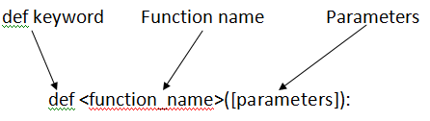

**Invoking a Function:**

To execute a function it needs to be called. This is called function calling.

Function Definition provides the information about function name, parameters and the definition what operation is to be performed. In order to execute the Function Definition it is to be called.

**Syntax:**

<function_name>(parameters)

</function_name>

eg: sum(a,b)

here sum is the function and a, b are the parameters passed to the Function Definition.

## return Statement:

return[expression] is used to send back the control to the caller with the expression.

In case no expression is given after return it will return None.

In other words return statement is used to exit the Function definition.

Data science

Numpy

Pandas

Mathplotlib

Nltk

Sklearn